TASK 1: ML CLASSIFICATION
Telcom Customer Churn Prediction

InternSpark Internship Project

1. Objective
Build and evaluate a supervised binary classification model to predict whether a telecom customer will churn (leave the service). The goal is to compare at least two algorithms and report standard evaluation metrics.

2. Dataset
- Source: IBM Telco Customer Churn Dataset (publicly available on GitHub)
- Rows: 7,043 customers | Columns: 21 features
- Target Column: Churn (Yes = 1, No = 0)
- Class Distribution: ~73.5% No Churn, ~26.5% Churn (imbalanced dataset)
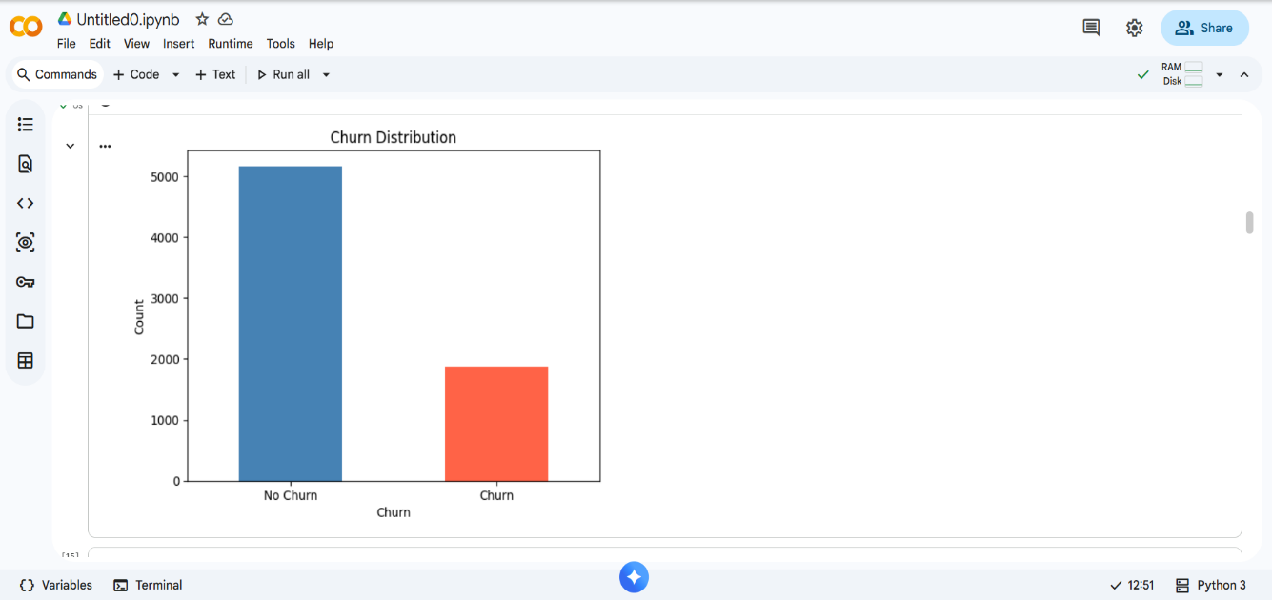
- Features include: Tenure, Monthly Charges, Total Charges, Contract type, Internet Service, Payment Method, and more
z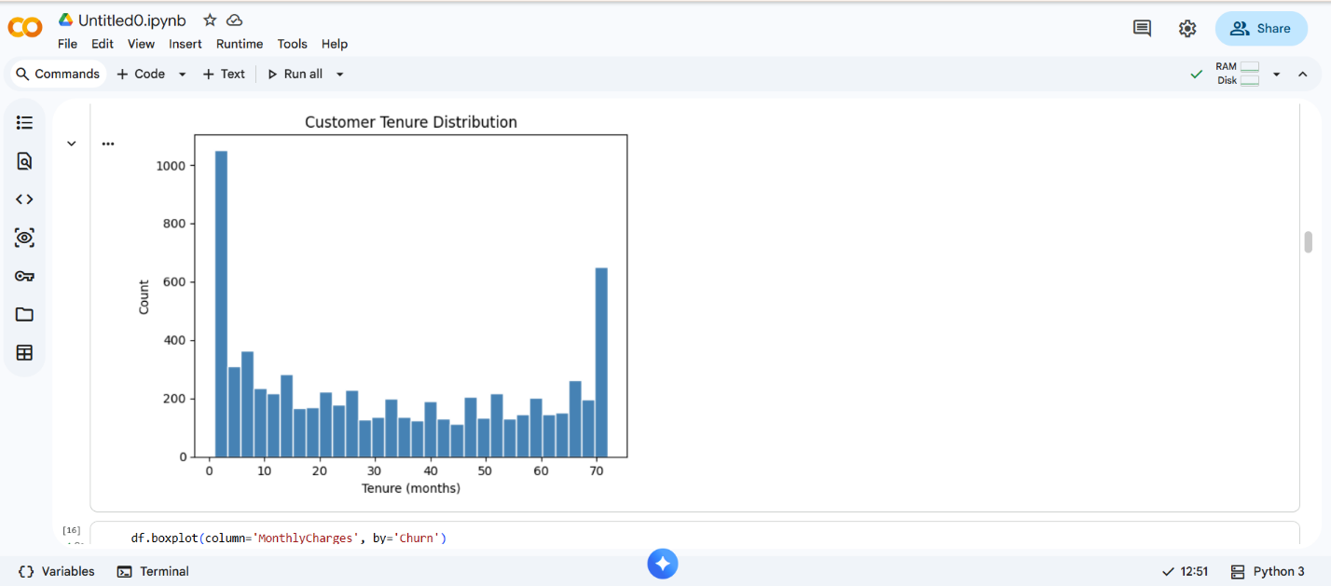

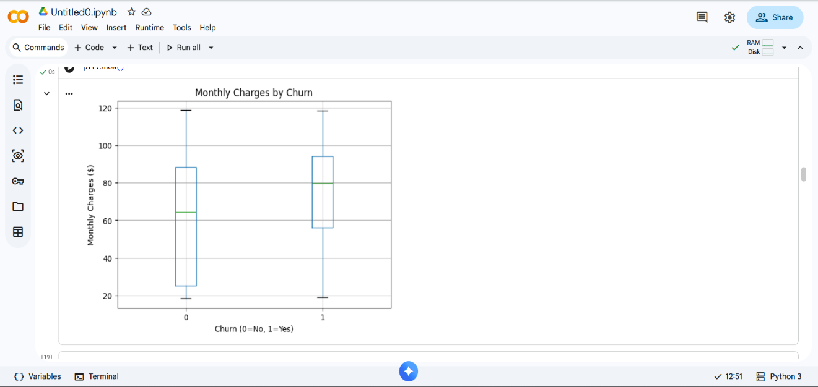

3. Environment Setup

Requirements
Python 3.10+
pandas, numpy, scikit-learn, matplotlib, seaborn, joblib

# Install all dependencies
pip install pandas numpy scikit-learn matplotlib seaborn joblib

Run the Notebook
# Option 1: Google Colab (recommended)
# Upload task1_ml_classification.ipynb to https://colab.research.google.com
# Run All Cells: Runtime > Run All

# Option 2: Jupyter Notebook (local)
jupyter notebook task1_ml_classification.ipynb

4. Data Preprocessing
Step | Action
Type Conversion | TotalCharges converted from string to float using pd.to_numeric()
Missing Values | 11 rows with null TotalCharges dropped (0.15% of data)
Feature Removal | customerID column dropped — non-informative for prediction
Target Encoding | Churn: Yes → 1, No → 0 using .map()
Categorical Encoding | All text columns label-encoded using sklearn LabelEncoder
Train/Test Split | 80/20 stratified split — preserves 26% churn ratio in both sets
Feature Scaling | StandardScaler applied to training set; transform only on test set

5. Exploratory Data Analysis
Four visualizations were created to understand the data distribution and feature relationships:

- Bar Chart Churn Distribution: Confirmed class imbalance (~26% churn rate)
- Histogram Tenure: Bimodal distribution with peaks at 0-5 months (new customers) and 65-72 months (loyal customers)
- Boxplot Monthly Charges by Churn: Churned customers pay significantly higher monthly charges
- Correlation Heatmap: Tenure shows strong negative correlation with Churn; Total Charges and Monthly Charges show moderate negative correlation
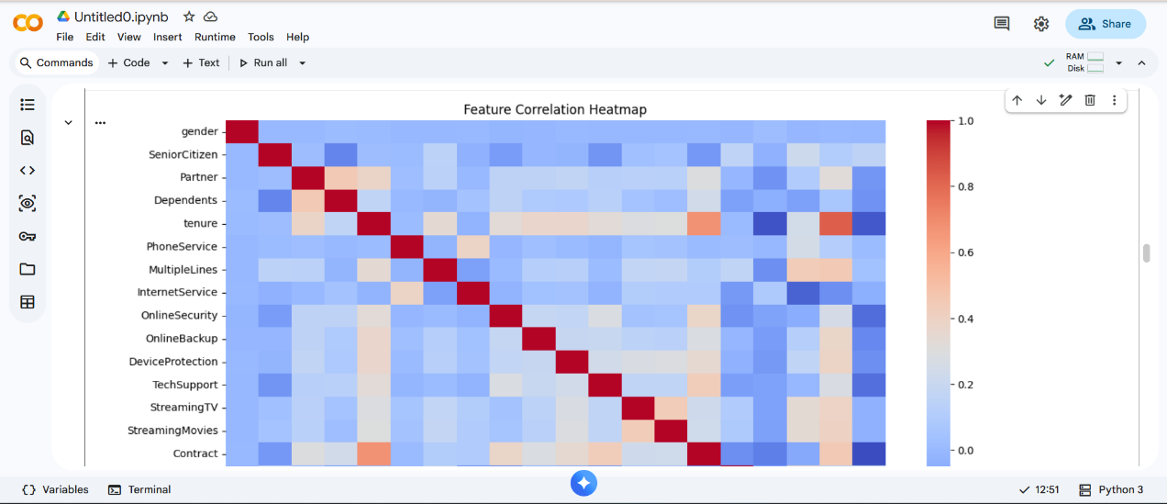
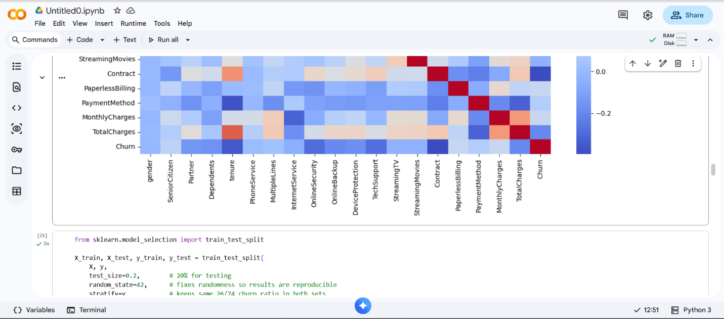Key Insight: Customers with short tenure and high monthly charges are at highest risk of churning

6. Models

6.1 Logistic Regression
- A linear model that learns a decision boundary separating churners from non-churners
- Parameters: max_iter=1000, random_state=42, L2 regularization (default)
- Requires feature scaling Standard Scaler applied before training

6.2 Random Forest Classifier
- An ensemble of 100 decision trees each tree votes and majority wins
- Parameters: n_estimators=100, random_state=42, n_jobs=-1
- Does not require feature scaling handles raw features directly
- Provides feature importances useful for model interpretation

7. Results & Evaluation

7.1 Metrics Comparison

Metric | Logistic Regression | Random Forest
Accuracy | 0.7946 | 0.7832
Precision (Churn) | 0.6237 | 0.6190
Recall (Churn) | 0.5642 | 0.4840
F1-Score (Churn) | 0.5925 | 0.5427
ROC-AUC (CV) | 0.8443 ± 0.0014 | 0.8241 ± 0.0041

7.2 Cross Validation
5-fold Stratified Cross Validation was used to ensure results are not dependent on a single train/test split:

- Logistic Regression CV ROC-AUC: 0.8443 ± 0.0014 (highly stable)
- Random Forest CV ROC-AUC: 0.8241 ± 0.0041 (more variance across folds)

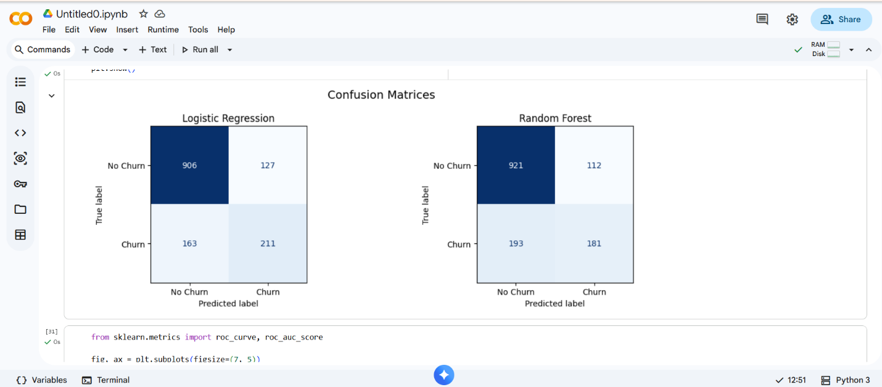

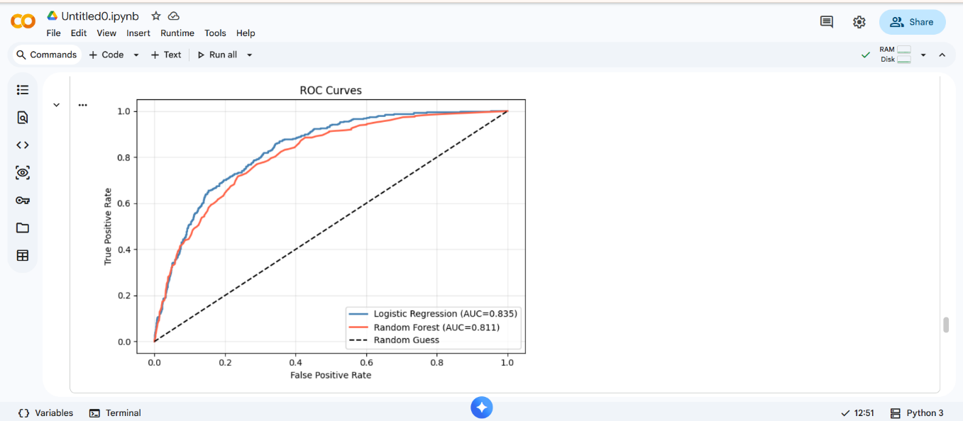

8. Feature Importance
Random Forest feature importances reveal the top predictors of churn:

- 1. Total Charges : total amount paid over the customer lifetime
- 2. Monthly Charges : current monthly bill amount
- 3. Tenure : number of months as a customer
- 4. Contract type, Internet Service, and Payment Method also contribute

Interpretation: Customers who have high monthly bills but short tenure are most likely to churn. Long-term customers are far more loyal regardless of charges.
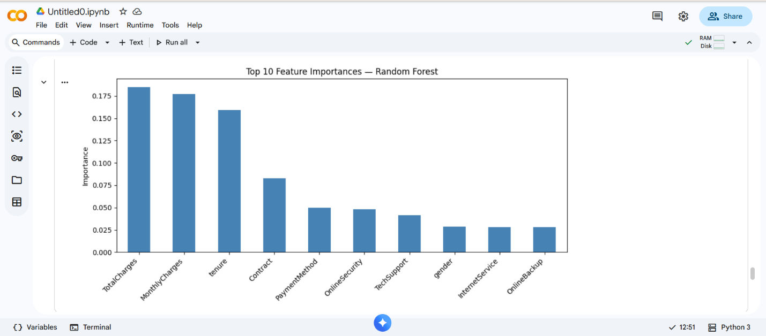

9. Model Selection & Conclusion
Selected Model: Logistic Regression

Reasons for selection:
- Higher ROC-AUC score (0.8443 vs 0.8241) across 5-fold cross validation
- More stable results (lower standard deviation: ±0.0014 vs ±0.0041)
- Better Recall on churn class (0.5642 vs 0.4840) critical for this use case
- Fully interpretable via coefficients business teams can understand predictions
- Lightweight and fast suitable for real-time API deployment (Task 3)

Key Challenge: Class imbalance (~26% churn) caused the model to be biased toward predicting No Churn. Future improvements could apply SMOTE oversampling or class_weight='balanced' to improve churn recall further.

10. Future Improvements
- Apply SMOTE oversampling to handle class imbalance
- Hyperparameter tuning with GridSearchCV
- Try XGBoost or LightGBM for potentially better recall
- Add SHAP values for deeper model interpretability (Task 4)
- Deploy as REST API with FastAPI + Docker (Task 3)

11. Deliverables
- task1_ml_classification.ipynb : Full notebook (Google Colab / Jupyter)
- task1_submission.docx :This document
- churn_model.pkl :Saved Logistic Regression model
- scaler.pkl : Fitted StandardScaler
- feature_names.pkl :List of feature column names
- GitHub Repository: https://github.com/Harini052006/ML-churn-prediction

